Text Categorization
Assignment 3

By Low Choon Meng (U053736R)
Chua Kien Chuan (U087140B)
Xu Wei Jie (U057020R)

Abstract
For this assignment, we are to implement a system to perform text categorization and of at least 2 categorization methods: kNN (k Nearest Neighbour) and Decision Tree.

Implementation

Design & implementation of algorithm
Since there are two different methods to be applied in this module, our algorithm is split into two parts: Decision Tree and K Nearest Neighbour. These two methods are implemented independently into two separate programs running on separate GUIs.

Modeling the problem

Heuristics used
In kNN, our model uses a similarity class to predict the distance between the input text to the training set. The k nearest nodes in the training set are used to determine our result. In addition to this, we have also implemented a TermSelection class. This is applied to the training set prior to training which effectively reduces the output set. TermSelection uses data frequency of the whole training set and removes the words that have high frequencies. The rationale is that in a conbined set, the extremely high data frequency words will not give very strong conclusion to the classification problem. In retrospect, words with low data frequencies within the individual categories of the training text are also removed. This is to filter some of the redundant words that are not common in the set of that particular category. However, in our project, this value is very low due to the small training set.
For the distance measure heuristics, we apply 2 different approaches. First, we tested the program by measuring the sum of distances of the k nearest neighbours in their individual categories. The category of the maximum sum is chosen. This approach handles the number of neighbours of the same category on top of the weights they carry. The other approach uses averaging of the sum of the distances of neighbours in each category. The category with the maximum average is chosen. This eliminates the frequency component in the neighbourhood leaving us with only the distance factor. Testing results have shown that using the first approach yields better results.
Decision Tree

Description of algorithm and methods
K Nearest Neighbour
Term Selection
Term Selection works on 2 threshold levels. DFThreshold is a lower bound threshold to filter unnecessary words that do not have meaning to the documents of the same category. This is done intuitively as words with less meaning to the same category of documents are usually of very low frequencies in the merged categorized database. IDFThreshold works on the other end, the higher the frequency of the words in the entire database, the least weight the words should carry. This is because these words do not give much classification power since it is too frequent in all the documents. Term selection basically allows the user to set the DFThreshold and IDFThreshold and would alter the stoplist accordingly so filter the words during stemming in the kNN calculation.
Similarity
Similarity class simply takes in 2 files. Compute the numeric number of the terms that intersect each other over the union of all the terms. It returns a double data type that ranges from 0 – 1.
Neighbour Distance Calculations
KNN uses the K nearest documents to classify a given document. The distances computed are exactly the numbers that represent the similarities between the stemmed representation of the given document and the training documents. These distances and their categories are stored into 2 arrays. A bubble sort is invoked to sort the 2 arrays in descending order with respect to the distances and pick the k largest of them all. Thereafter, we compute the summation of these k similarities for each individual category and pick the max of them. The category that has the highest similarity to the given document will be classified as the document as that.
Decision Tree
Tree Generation
For generating/learning the decision tree, there are many algorithms available. W-J48 produces a C4.5 type of tree. We have used RapidMiner to generate multiple trees with different pruning techniques for comparison. The tree with the highest accuracy is chosen for further tweaking. RapidMiner allows us to tweak certain tree pruning attributes by changing the minimum number of instances per leaf, confidence threshold for pruning/non-pruning and so on. This results in a more accurate tree structure.
Implementation of Model
We use the RapidMiner/Weka API to access the tree for tree traversal. During implementation, a process is created to access the model. On actual run, we apply the model to the data given from the test cases by means of the available API calls.

Problems encountered
When using the stemmer program provided, we realized that the structure of the algorithm produces a minor bug. The stemmer uses a stoplist to filter out certain words which are generic and has no important role for the classification of the text. However, the stoplist is only applied on the outputs of the stemmer after the documents are stemmed. As stemming causes words to be shortened to get the general form of the words, a bug in the stemmer program causes words to be shortened unnecessarily. This leads to some of the words which are present in the stoplist still getting into the output, creating a huge redundancy in the list. The inability to apply the stoplist effectively causes our accuracy to be reduced.
Decision Tree problems

Efficiency and Testing of programs
For the testing of the Decision Tree, we generated a performance vector using RapidMiner. The performance vector consists of all the files from the testing_corpus folder attached to the assignment and is tested on the decision tree. The results are as shown is the figure below:
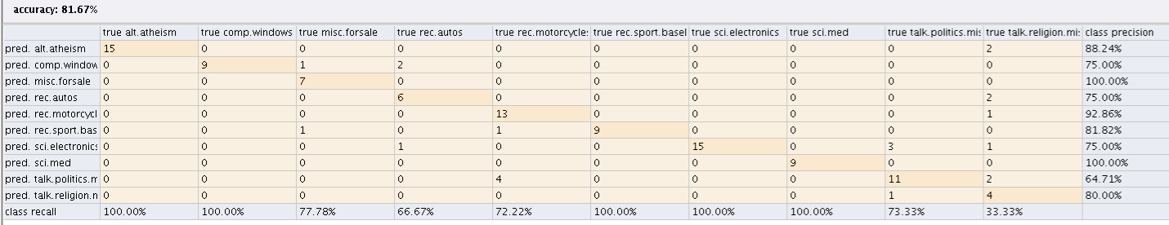
Total accuracy of the decision tree is 81.67% tested with the files in the testing_corpus folder. For the testing of the KNN algorithm, we ran a loop to simulate the training of the data using different df and idf values. We also use different k values to classify the test documents. As such, we generated the table below.
K | DF | IDF | Accuracy
1 | 4 | 3 | 0.61%
1 | 4 | 13 | 0.61%
1 | 4 | 11 | 0.60%
1 | 5 | 8 | 0.60%
1 | 1 | 11 | 0.59%
1 | 1 | 13 | 0.59%
1 | 1 | 7 | 0.58%
1 | 1 | 9 | 0.58%
1 | 1 | 15 | 0.58%

Future Enhancements

Conclusion
We have learned a lot from this assignment. In fact, for KNN and Decision Tree, a lot of effort was spent learning to train the data and setting up the model using RapidMiner. It was fruitful yet tiring experiences for us all.

